How to upload a single file in CastleBranch

1 Find file that you want to upload. Select and click Upload File button.

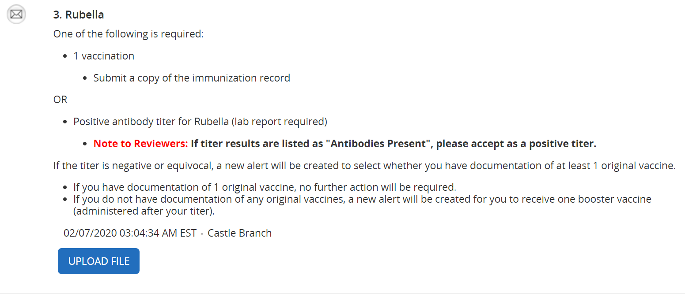

2.Upload form menu will appear select choose file.

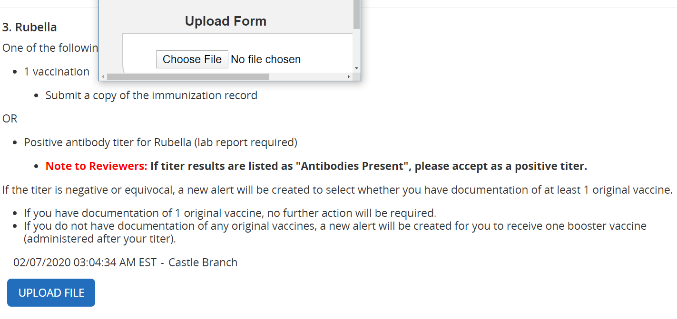

3.Then choose folder or location where the is located. Click file and click Open. File will appear in CastleBranch portal.

