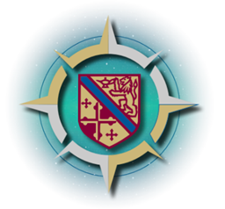

**Howard Community College Commission on the Future**

**Fostering Community Task Force**

Tuesday, October 18, 2022

12:30 p.m. – 2:00 p.m

[**https://howardcc.zoom.us/j/91990101507?pwd=dTF5NDFqcnd5V1BZUlJPM1g4aTlSdz09**](https://howardcc.zoom.us/j/91990101507?pwd=dTF5NDFqcnd5V1BZUlJPM1g4aTlSdz09)

**Task Force Co-Chairs:** Laura Bacon, Bita Dayhoff

**Community Members:** Tracy Brocolino, Peter Engel, Joel Frankel, Nikki Highsmith Vernick, Vivian Lawyer, Linda Zumbrun, Jackie Scott, Valeri Traore,

**President’s Team Representatives:**

Dr. Melissa Curtis, Lynn Coleman

**HCC Faculty and Staff:**

Yvonne Everett (Support Person), Christy Ewing, Mary Barton, Shelly Bilello, Sandy Cos, Shawn Lamb, Cynthia Paige-Desi, Aisha Rivers, Grace Anastasiadis

|  |  |  |
| --- | --- | --- |
| **Item** | **Person(s)** | **Outcomes** |
| Introductions | Laura | All internal and external TFMs shared their roles and agency affiliates. |
| Lay of the land | Bita | Discussed the role of the committee in the context of the commission’s role. |
| . |  |  |
| HCC Status Update | Sandy | * What is HCC already doing? * Where do they want to go? |
| Brainstorming Activity | Laura | Task force members used jamboard to present their ideas.  Shared Big picture questions. |

**Next meeting: Tuesday, November, 8, 2022, 12:30 p.m. – 2:00 p.m.**