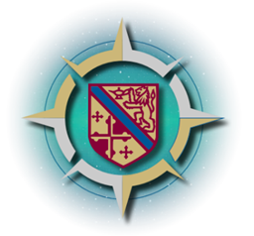

**Howard Community College Commission on the Future**

[Commission on the Future | Howard Community College (howardcc.edu)](https://www.howardcc.edu/cof/)

**Offering Early Pathways to College and Careers Task Force**

*The task force will explore opportunities for the college to develop*

*more opportunities for middle and high school students to explore college.*

*How can we expand dual enrollment?*

*How could we offer an early college experience*?

**Friday, November 4, 2022**

**10:30am – 12:30pm**

<https://howardcc.zoom.us/j/91082610601?pwd=dEtRakJJWlZGQTVacmlQTHZZWVk5dz09>

**Task Force Chair:** Dr. Dwight Carr

**Community Members:** Bill Barnes, Tony Breeze, Stephanie Brice, Nona Carroll, David Doggette, Aphaia Harper, Robert Hooten, Charan Johal, Tim Payne, Elizabeth Rendon-Sherman, Cindy Shao

**HCC President’s Team Representatives:**

Zoe Irvin, Dr. Carl Moore

**HCC Faculty and Staff:**

Katrina Bowers, Jenny Carr, Deborah Greenberg, Rebecca Morrow, Rob Rickenbrode

**Design Thinking Facilitator:** Emily Mintman

|  |  |  |
| --- | --- | --- |
| **Item** | **Timing** | **Person(s)** |
| **Introductions** | 10:30-10:45 | Dwight |
| **COF Overview** | 10:45-11:00 | HCC |
| **Overview of the method we are using to make recommendations** | 11:00 – 11:05 | Dwight |
| **Design thinking exercises** | 11:05 – 12:15 | Emily |
| **Reflection** | 12:15 – 12:25 | Emily/Dwight |
| **Next Steps** | 12:25 – 12:30 | Dwight/Jenny |

**Next meeting:** Monday, November 21, 2022, 12:00-2:00pm